Physics Stage 3: Practical Exam 3A

Name: __________________________________________ (35 marks)

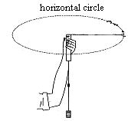
Question One:

Three students were investigation circular motion in a similar manner to the investigation you carried out earlier this year. They swung a weight around in a horizontal circle with a known radius and collected the results below:

mass of stopper = 0.0320 kg
average time for 20 turns = 8.80 s
radius of swing = 0.600m
mass hanging from fishing line = 0.400 kg
- Calculate the weight of the mass supplying the gravitational force. (2 marks)
F_{w} = mg
= 0.40 x 9.8 (1 mark)
F_{w} = 3.92 N (1 mark)

- Calculate the centripetal force on the stopper. (4 marks)
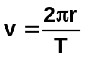 F_{c} = 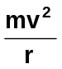
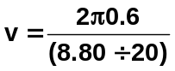 F_{c} = 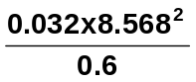 (1 mark)
(1 mark for T value) F_{c} = 3.915
v = 8.568 m s⁻¹ F_{c} = 3.92 N (1 mark)
(1 mark)

- Compare the weight of the hanging mass with the centripetal force on the stopper. What do these results show and does this agree with the expected result? Explain. (3 marks)

The weight of the mass and centripetal force have a similar value. (1 mark)
This shows that F_{w} = F_{c} (1 mark)
This is to be expected as the centripetal force is supplying the force that supports the
weight force. (1 mark)

d. Often, when this experiment is performed, the string holding the stopper is not exactly horizontal. How does this affect the experiment? Explain. (3 marks)

Yes (1 mark)
If not horizontal, tension in string is actually F_{T} = F_{c} + (F_{w} sin θ) (1 mark) which is greater than F_{c}. (1 mark)

Question Two

In this experiment, an aluminium strip is firstly swung backwards and forwards until it stops (figure 1). The bar takes 19 seconds to stop. Two strong magnets are then placed so that the strip can now swing between them (figures 2 and 3). The bar now takes 7 seconds to stop. Explain the difference in time taken to stop. (4 marks)
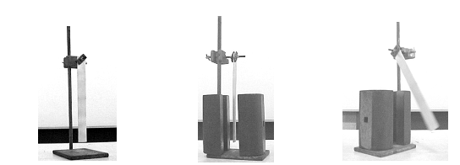
Figure 1 Figure 2 Figure 3

As the aluminium bar swings between the magnets, it experiences a changing magnetic field. (1 mark)

The changing magnetic field induces an emf in the aluminium. (1 mark)

The emf induces Eddy currents in the aluminium which in turn produce their own magnetic field. (1 mark)

According the Lenz’s Law, the induced magnetic field in the aluminium is set up to oppose the initial magnetic field between the magnets and thus a force is applied to the aluminium thus slowing it down. (1 mark)

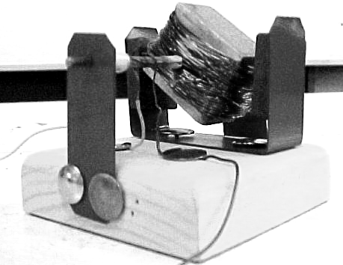
Question Three
This device is a simple DC motor. Give three ways in which you could increase the speed of this motor. (3 marks).

- increase number of magnets (increase B)
- increase number of coils (increase )
- increase current (increase I)
Question Four
In an activity to investigation resolution of forces, you set up the apparatus as shown.
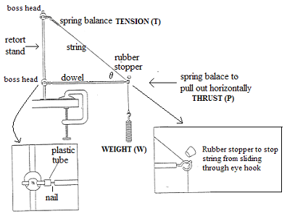

- The weight of the beam in this experiment was ignored. Was this reasonable and does this mean the beam has no effect on the experiment? Explain. (3 marks)

It is reasonable to ignore the beam as its weight is very small compared to the weight, W.
(1 mark)

This is however an equilibrium situation and therefore the weight of the beam would increase the tension in the string but not significantly. (2 mark)

- The data from one student’s results was W = 4.9 N and P = 7.6 N however he forgot to record the angle. Assuming his set-up was very accurate, determine the tension in the string and the angle between the beam and the string. (3 marks)

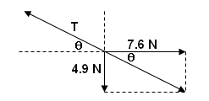
T = 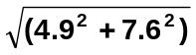 (1 mark)
= 9.0 N (1 mark)
θ = Tan⁻¹ (4.9 ÷ 7.6)
= 33⁰ (1 mark)

Question Five
A student was investigating how the magnetic force on a current-carrying conductor at right angles to a magnetic field depended on the current and magnetic flux density.

He set up the experiment and measured the current in the solenoid and the current in the current-carrying conductor. His results are shown below. He then calculated the magnetic flux density.

Current in solenoid  (A) | Current in current-carrying conductor (A) | Magnetic Flux Density  x 10⁻³ (T)
0.50 | 1.881 | 2.21
1.20 | 1.335 | 3.11
1.85 | 1.034 | 4.01
2.30 | 0.920 | 4.49
3.00 | 0.766 | 5.42

- On the graph paper provided, draw a graph of magnetic flux density vs current in solenoid.
(5 marks)
- What relationship is shown by the graph? (2 marks)
Directly proportional (1 mark)
As current increases so does the magnetic flux density in the solenoid

- Using the graph, calculate the gradient of the graph in the space below. (3 marks)
gradient values should be shown on graph (1 mark)
gradient = 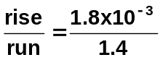
= 1.3 x 10⁻³ T A⁻¹
(1 mark) (1 mark)

NB: Should be no more than 2 significant figures – deduct 1 mark if more given.

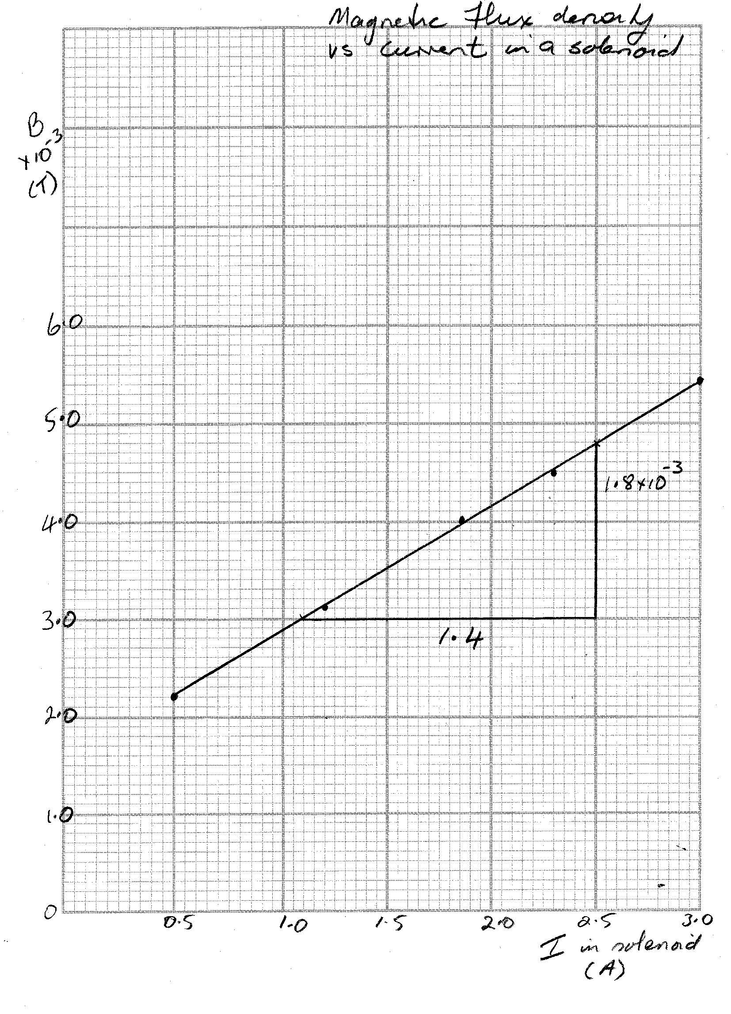
Marks:
axis correct 1 mark
axis labelled 1 mark
point correctly plotted 1 mark
line of best fit 1 mark
title 1 mark

